Installation Manual to Update e-Sahulat version 1.0.3.0 to e-Sahulat version 1.1.1.2 and RTF version 2.04
Step 1.
Installation Procedures of e-Sahulat version 1.1.1.2
Prerequisites:
Following are the prerequisite software needs to install for e-Sahulat version 1.1.1.2
- Window Installer 3.0 or latest.
- Dot Net Framework version 2.0 or latest
- Java Run Time Environment 5.0 or latest

Note : Please ignore pre-requisites if you are already running e-sahulat ver 1.0.3.0

e-Sahulat Version 1.1.1.2
- Double Click/Run installer package e-Sahulat.exe
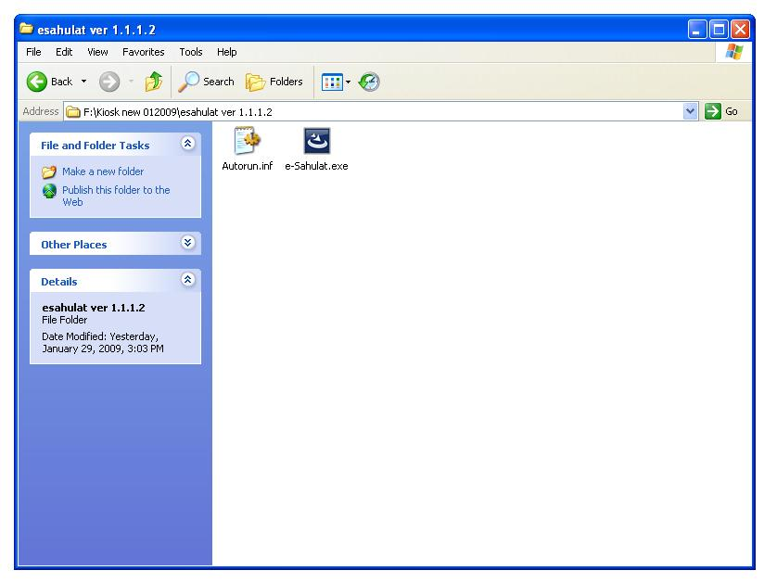

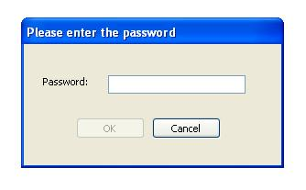
- Enter password “nadra”

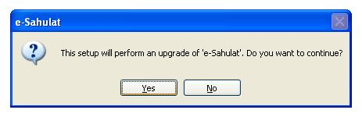
- Click “YES” to upgrade the e-Sahulat version 1.0.3.0 to e-Sahulat version 1.1.1.2

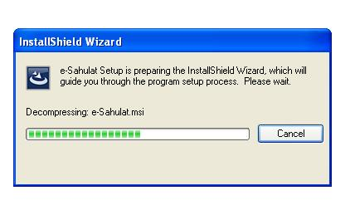
- Installation will be started.

- Click “NEXT”
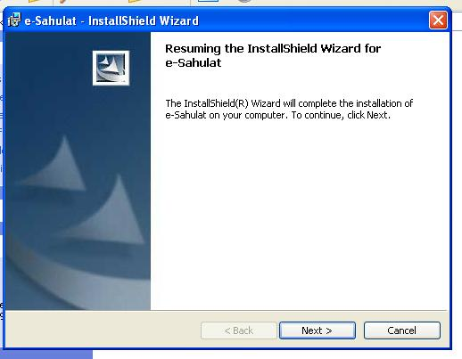

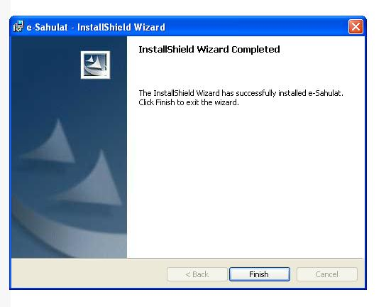
- Click “FINISH“ to finish the installation.

Step 2.
Registering Private Key and Machine

- Double Click/Run EchoSystemID from desktop OR
Click/Run START →Programs→Nadra→e-sahulat→ EchoSystemID
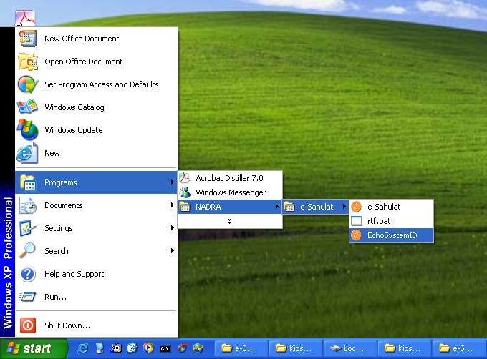

- Before running EchoSystemID, please ensure that Private and public keys are already on their places.
- A file named as SystemID_<e-Sahulat id>.txt will be generated on the desktop
- Open SystemID_<e-Sahulat id>.txt, highlight and then copy the whole code.
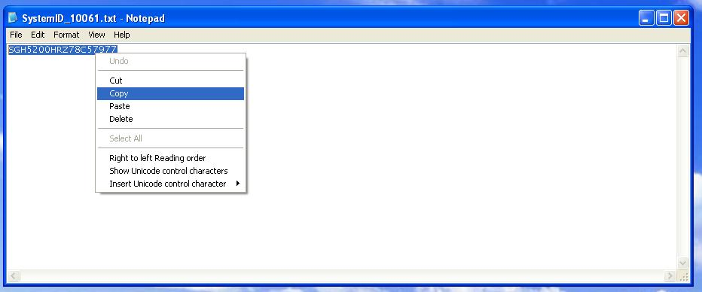

- Open e-Sahulat reporting web site using your own (franchisee’s) user name and password which has already been provided.
- Click on link “Change Machine ID”.
- Paste the code in the text field provided for Machine ID.
- Click on “Submit” button
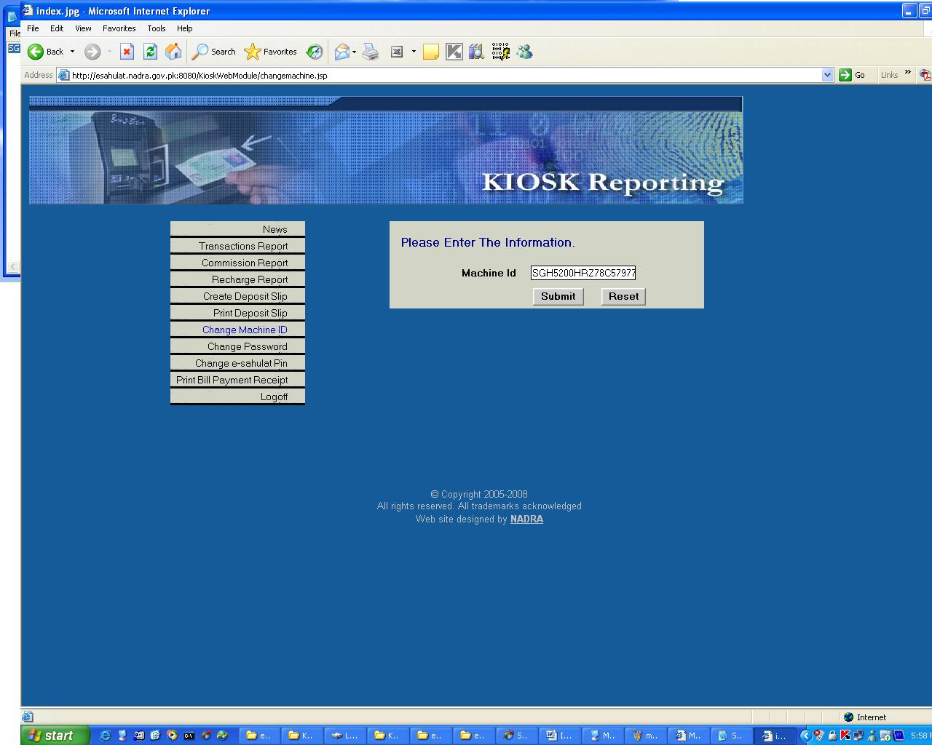

- Registration of Private Key and Machine is completed.

Notes:
e-Sahulat version 1.1.1.2 will not work with out performing Step 2.

